Web Design and Development

4COSC011W

Report

Author:

Student ID UOW :w1954036

Student ID IIT : 20221256

Group Number:

Student Role: Student 2

Link(s) to WebSite

URL:

1. Introduction 2

2. Technical Discussion 3

• Task 1 3

• Task 2 3

• Task 3 3

• Task 4 3

• Task 5. 3

• Task 6. 3

3. Webpage Validation Statement 4

4. Janet 4

References 4

Appendices 4

Appendix A: Code 4

Appendix B: Screenshots 4

Appendix C: Screenshots - Webpage Validation Evidence 4

Appendix D: Individual Statement 5

Appendix E: Task Completion Checklist 6

# Introduction

Topic :

* Tourism

## Group members:

* Student 1 : Visal Witharana
  + Presentation page
  + Buy product
* Student 2 : Didula Senevirathna
  + Home page
  + Comment Form
* Student 3 : Piyumdi Liyanage
  + Quiz
  + Student Details
* Student 4 : Disadi Arachchi
  + SVG
  + Image Gallery

Section guidelines:

1. List of the team members, allocation of tasks (student 1 to 4), and topic of the website.
2. Include the summary table of your contributions to the group meetings.

| **Group Coursework Meetings** (minimum 5 meetings, e.g., one per week) | | |
| --- | --- | --- |
| **1** | **Date & Time** |  |
| **Objective:** |  |
| **Attended:** |  |
| **Your Contribution:** |  |
| **2** | **Date & Time:** |  |
| **Objective:** |  |
| **Attended:** |  |
| **Your Contribution:** |  |
| **Etc….** | | |

# Technical Discussion

All team members agreed to create the page in tourism. What we needed was to create a web site to sell tourism packages to tourists. We have used a common navigation bar, common footer and a mostly common colors within the website.

**Student 2 Role:**

As student 2 I had to create the home page and the comments form.

## 2.1 Home Page

The home page contains a video slider and different texts related to different tourism categories. The user has to click on the slider buttons to go through different slides. The slider is created using java script. At the bottom of the page, there are links to the additional pages. Common navigation bar and Footer are used. We have used same common styles which other pages used in the home page.

**HTML code**

Video slider is the main element of the home page. All videos are imported using <video> tags. Relevant class names are given. Same video has inserted 3 times because video has to be started from the beginning when slider buttons are clicked. First content to be displayed has been set to “active” because it has to be started automatically.

Links to the additional pages are created in the bottom section of the home page. Links are created on the relevant images. Hover effects area added to the images.

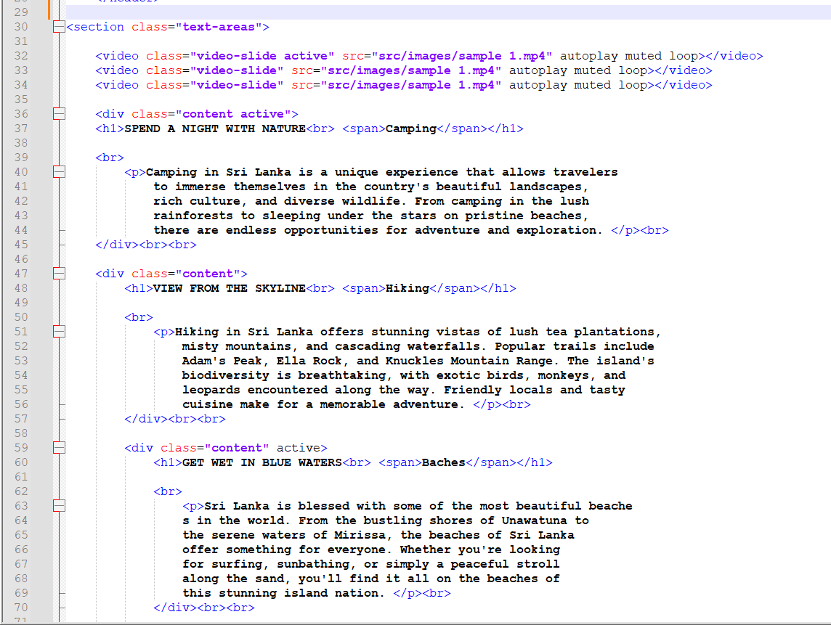

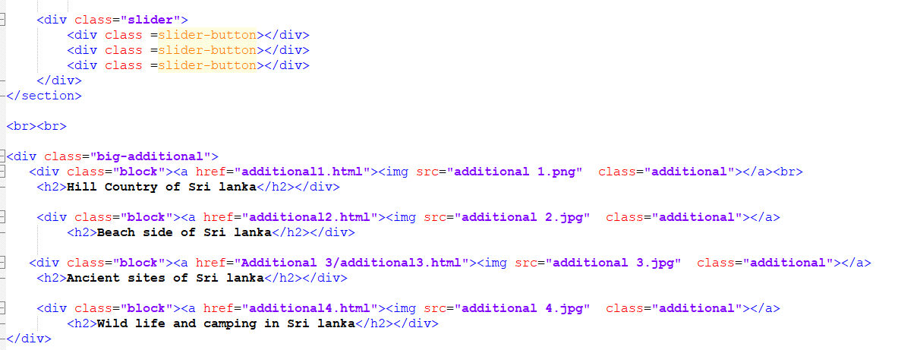

**CSS Code**

Most of the texts have been taken to different div areas when styling. Common features for each div area have been added under the relevant class associated for the div area.

:hover is used to describe hover effects on classes and agba color codes have been used to make the background transparent.

Margin left, right, top and bottom are used to get empty space to the element from left, right ,top or bottom.

Transition and transform tags are used to hive the zooming effect on hour.

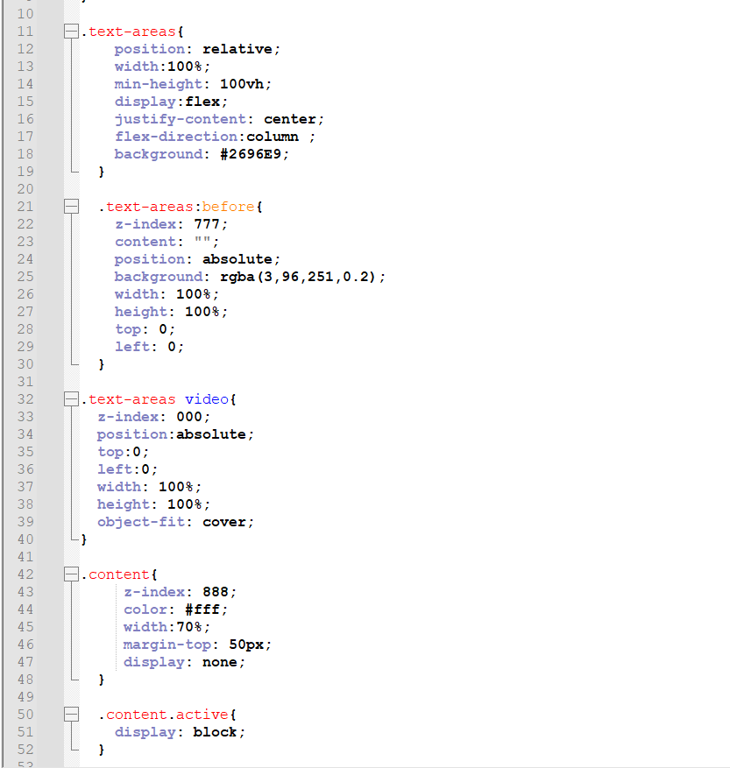

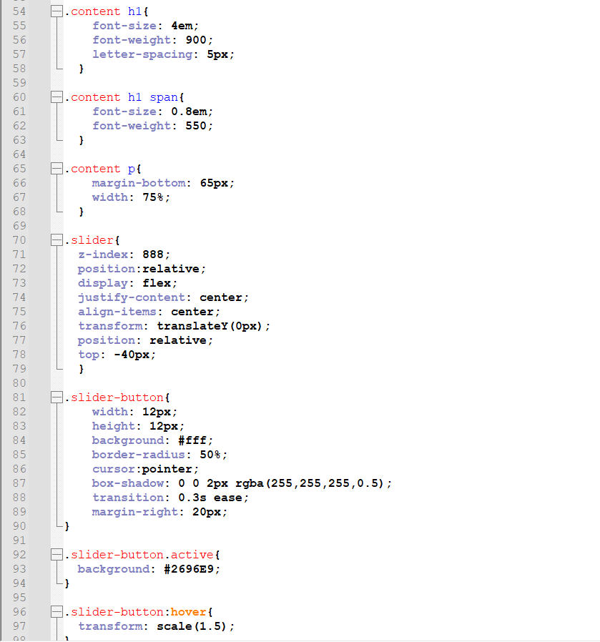

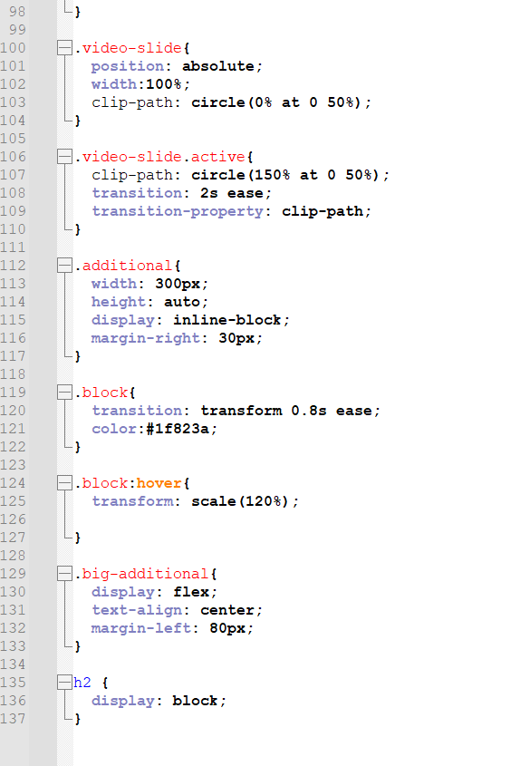

**JavaScript Code**

JavaScript code is used to make the navigation buttons active. Code is written to slide between different texts and open the video again when the button is clicked.

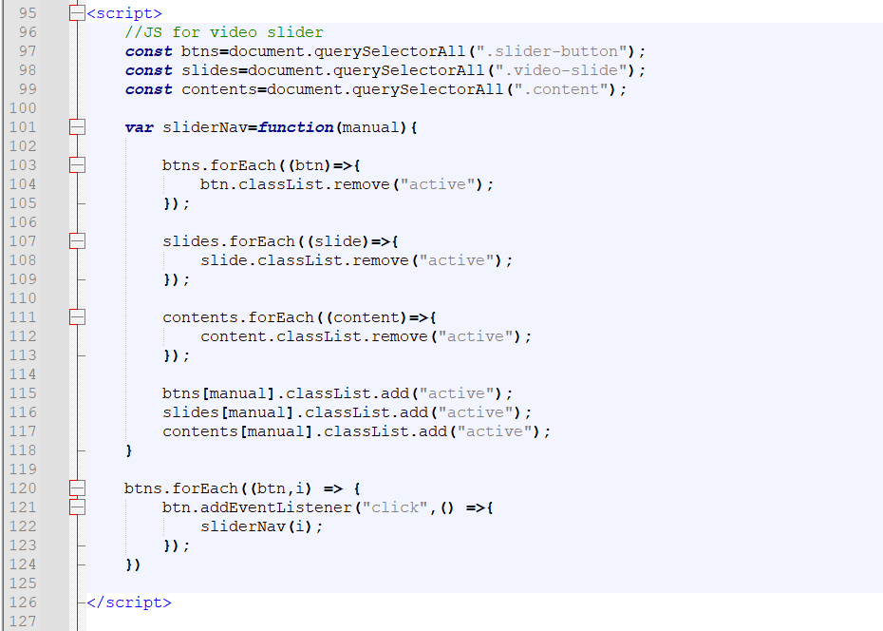

## Comments Form

**HTML Code**

Text fields have been taken to get the first name and the last name of the user.

Then the rating is taken through radio buttons. After reason for the rating is taken using a text area.

Then 2 dropdown lists have been used to take the next 2 values.

All the elements have been written inside respective div areas to be easy to style and access.

Placeholders to text fields have added to display default message that what to be applied to that fields by the user.

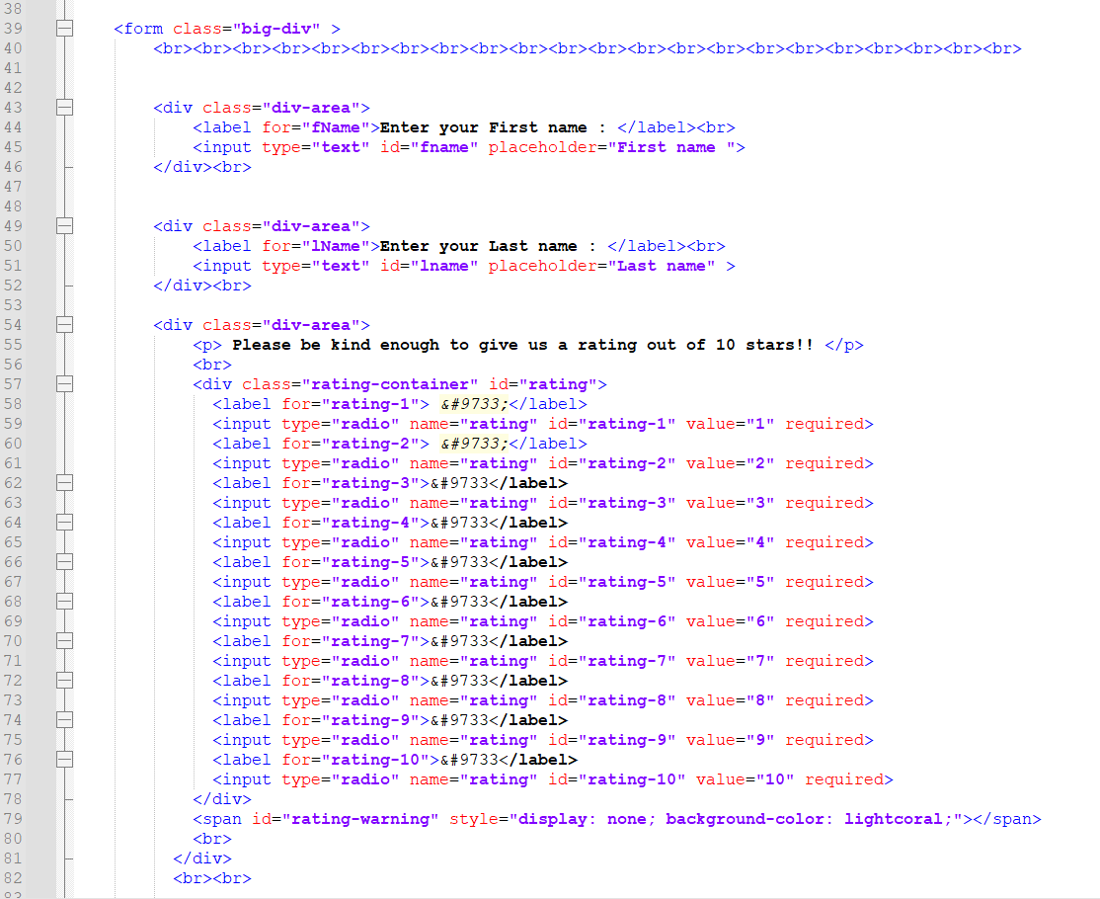

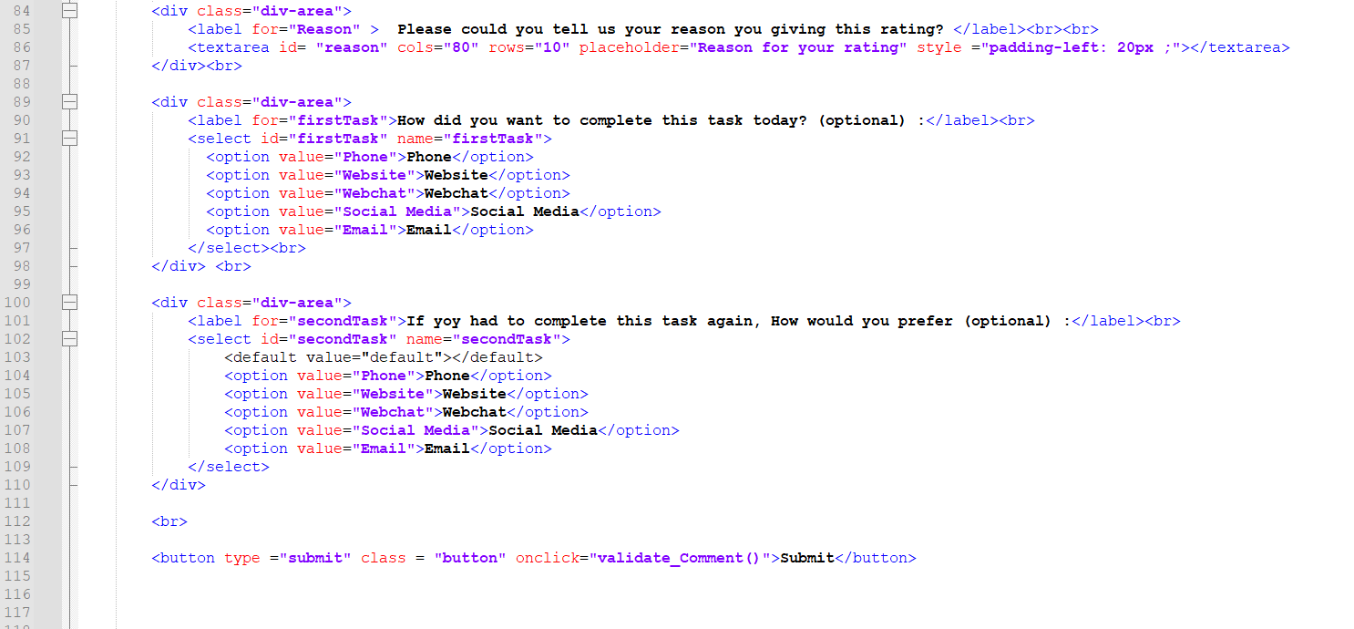

**CSS Code**

Most of the CSS techniques used are same as in the home page.

Special CSS is used to make the rating radio buttons appear like stars. Before and after color changes, hover effects are added to the rating field. All the stars are displayed horizontally.

When hovering, zooming effects (using transform) color changes, background color changes are added to every input field when hovering.

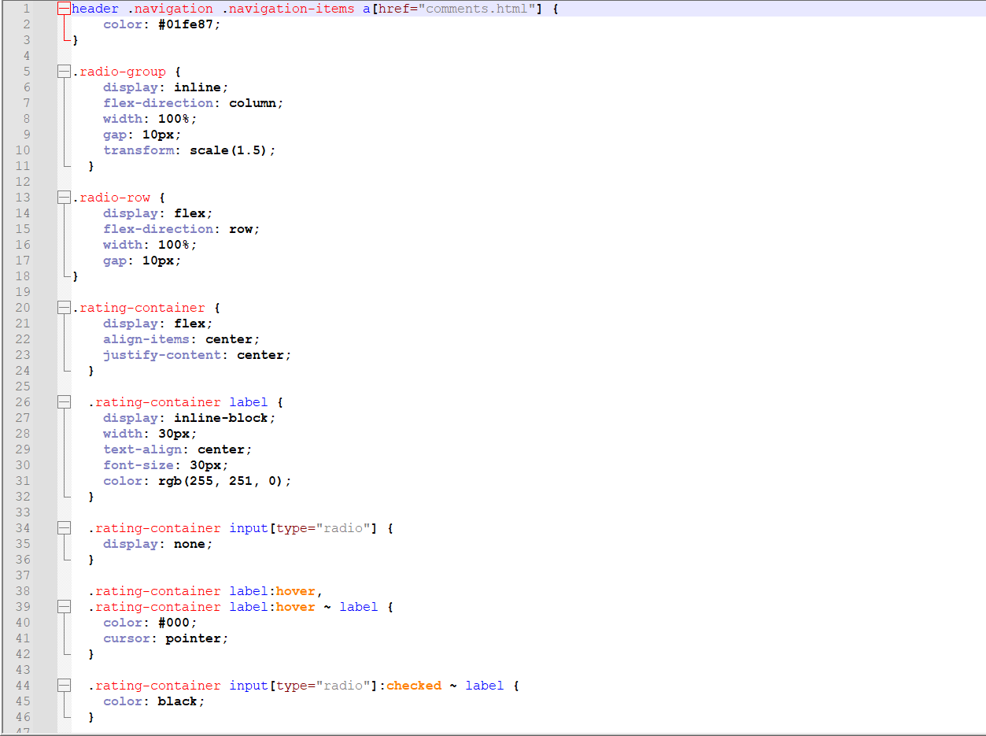

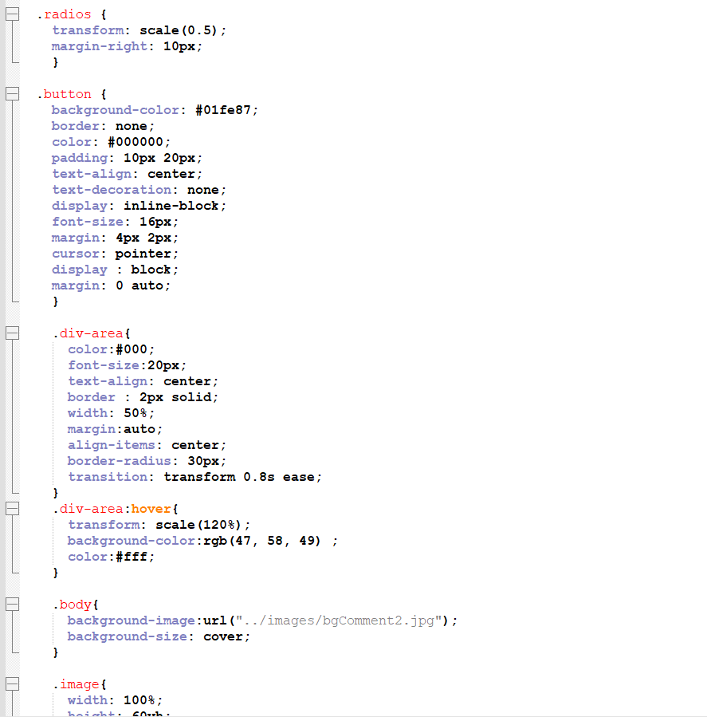

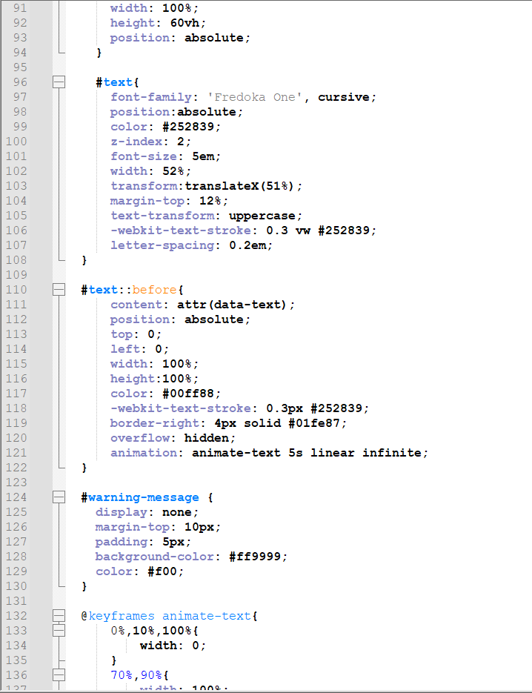

**JavaScript Code**

All the functions are written to validate non optional input fields and to send the email.

SendSubmitEmail () function is used to create the content of the email to be sent. All the content of the email is stored inside of the object emailBody. Then it is added to the email using the format (key,value). New line is taken using “\n”. Mailto function is used to send the e mail to my email account.

All the text fields arr validated by simply checking that are the empty strings. If they are empty, an alert is given to the user and requests for the value again.

Value of the each radio button is taken in to an array and it is checked that does it contains a value. If all values are empty, user is alerted to give the rating again.

2 dropdown lists are not checked because they are not compulsory to fill.

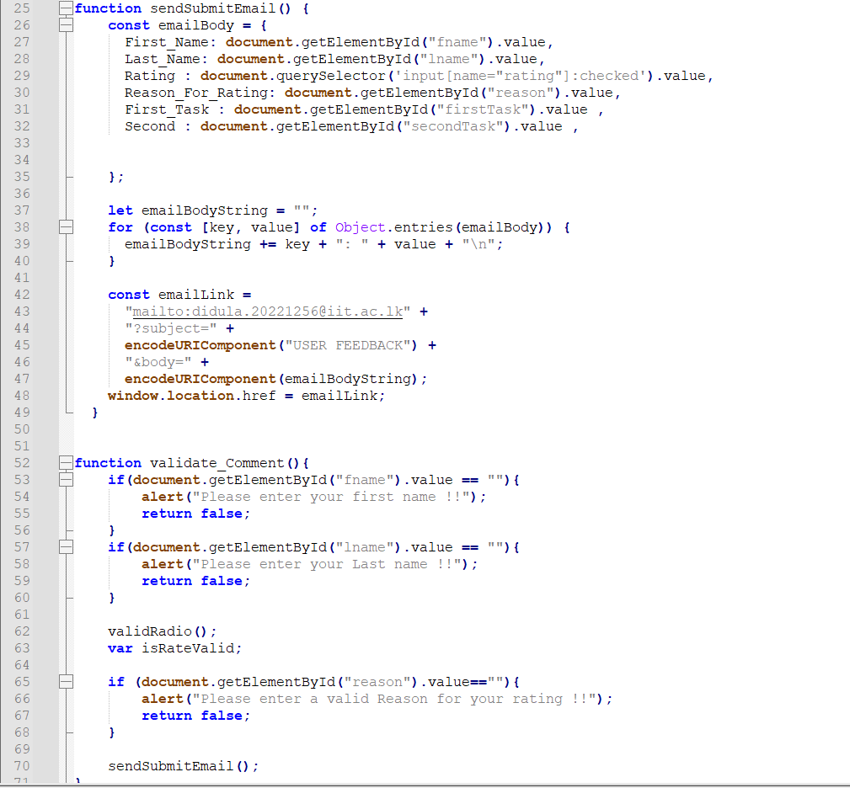

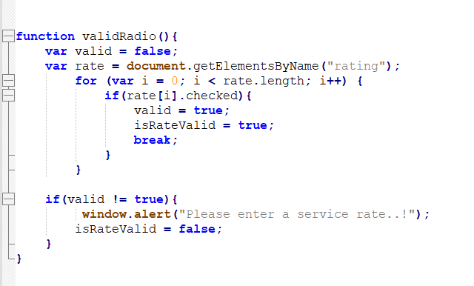

## Navigation bar

**HTML code**

Navigation bar is written inside the header tag. All the main web pages are linked to the relevant text using <a> tags

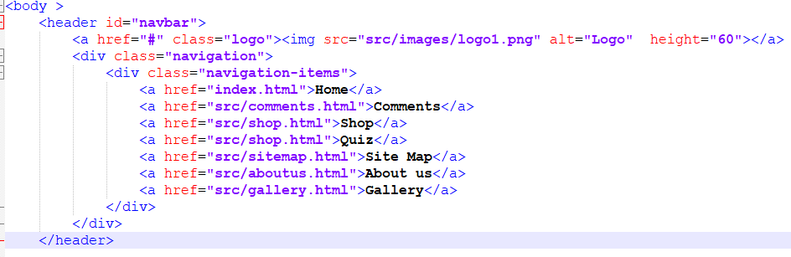

**CSS code**

Colors of the navigation bar are changed using the CSS codes

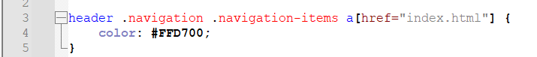

**JavaScript code**

ChangeBg() function is used to change the colors when controls are happening on the navigation bar

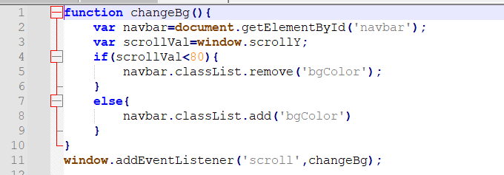

## Editor page

**HTML code**

All the tasks I have done in developing this web site are displayed here. Heading tags are used to display basic information about my self. Main tasks I have done are given under lists.

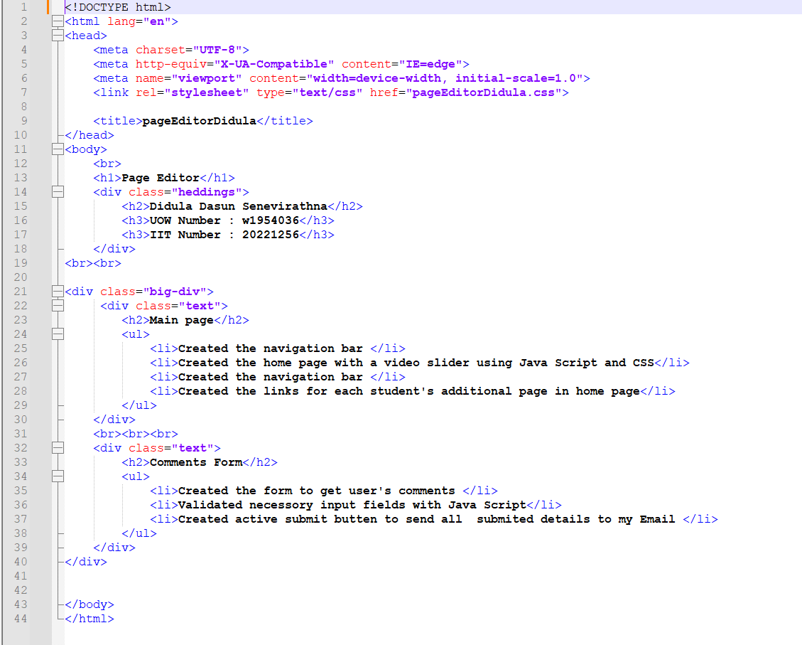

**CSS code**

Heading tags are used and background color, text color re changed using CSS. Heading of the page is centered within the given width.

Background image is added.

Heading of the lists are centered and list items are aligned to left. Border and border radius are given to list area.

Background of the list div area is faded using rgba color codes.

Hover effects are given and when hovered, zooming, text color changing and background color changing are happening.

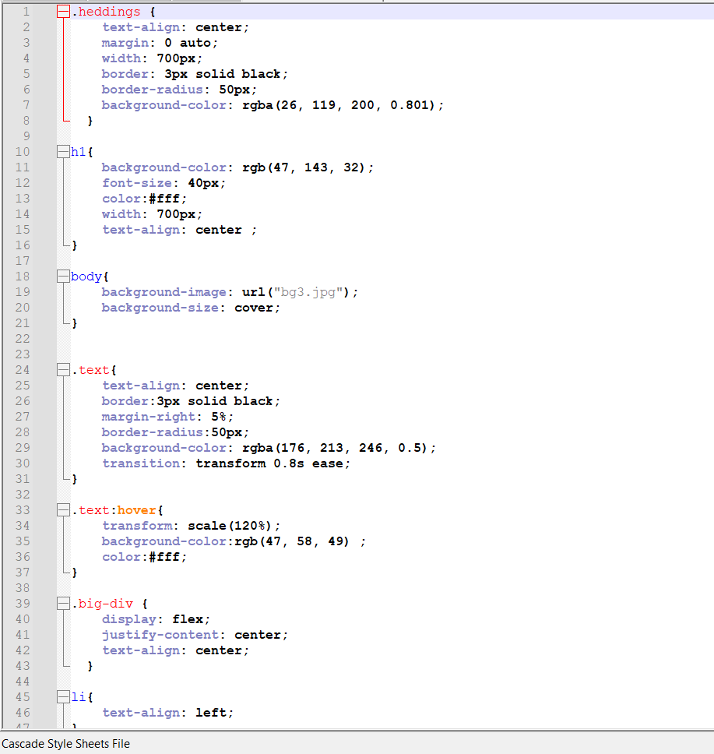

## Additional content page

**HTML code**

We are developing this web site about tourism in Sri lanka. So I selected ancient cities to make my additional web page.

Title of the new page is Ancient sites in Sri lanka.

Heading tags are used to give city names and content is written inside <p> tags. Div tags are given as needed to do styling.

Finally a button that links to editor page is created.

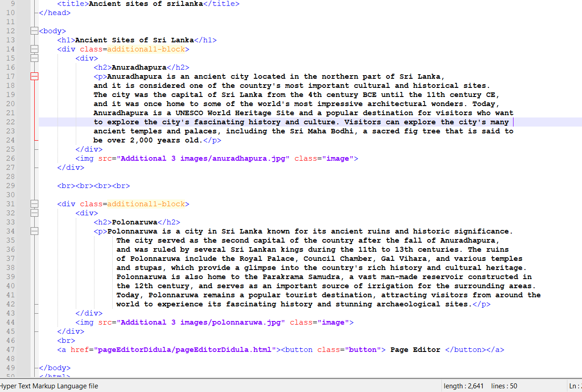

**CSS code**

**Heading** tags , hover effects and other common styling techniques are added. Image and the text are taken to the same line using flex option.

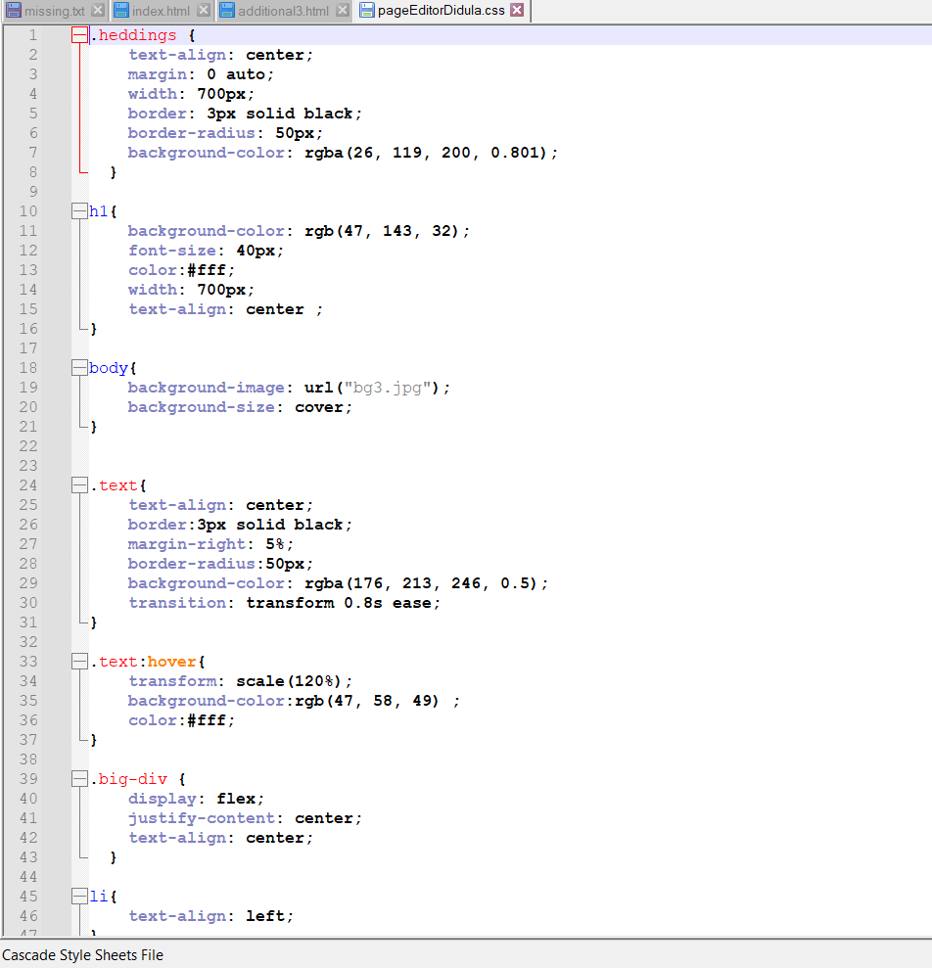

# Webpage Validation Statement

Briefly state which three of your web pages validated without errors. Put the screen shots of the validation results in Appendix C.

# Janet

I have ensured that this website conforms with the necessary JANET rules as its creator. The Joint Academic Network (JANET) offers educational and research institutions in the UK a network infrastructure and related services.

I have adhered to the recommendations made by JANET on their website, which cover accessibility, security, and privacy precautions, to ensure compliance. For instance, I have taken steps to ensure that those with disabilities may visit my website by including alternative language for photos and employing a readable font size and color scheme.

On my website, I've got a privacy statement that describes the kinds of information that are gathered, how they're utilized, and with whom they're shared. The General Data Protection Regulation (GDPR) is in compliance with this policy, which makes sure that user data handling on my website is disclosed in a clear and understandable manner.

Additionally, I have taken precautions to make sure that my website is free of any hazardous or malicious content that can endanger visitors. This involves performing routine software and plugin updates to guard against any potential security flaws.

Overall, I am convinced that my website conforms with all the JANET rules and offers all users a secure and convenient experience.

# References

[CSS Tutorial (w3schools.com)](https://www.w3schools.com/css/default.asp)

[JavaScript Tutorial (w3schools.com)](https://www.w3schools.com/js/default.asp)

[HTML Tutorial (w3schools.com)](https://www.w3schools.com/html/default.asp)

# Appendices

## Appendix A: Code

**Home page HTML code**

<!DOCTYPE html>

<html lang="en" xmlns="http://www.w3.org/1999/xhtml">

<head>

<title>Tourism SL</title>

<link rel="stylesheet" type="text/css" href="src/css/temp.css">

<link rel="stylesheet" type="text/css" href="src/css/main.css">

<script src="src/script/temp.js"></script>

<link rel="preconnect" href="https://fonts.googleapis.com">

<link rel="preconnect" href="https://fonts.gstatic.com" crossorigin>

<link href="https://fonts.googleapis.com/css2?family=Open+Sans:wght@500&display=swap" rel="stylesheet">

<meta charset="utf-8" />

</head>

<body >

<header id="navbar">

<a href="#" class="logo"><img src="src/images/logo1.png" alt="Logo" height="60"></a>

<div class="navigation">

<div class="navigation-items">

<a href="index.html">Home</a>

<a href="src/comments.html">Comments</a>

<a href="src/shop.html">Shop</a>

<a href="src/shop.html">Quiz</a>

<a href="src/sitemap.html">Site Map</a>

<a href="src/aboutus.html">About us</a>

<a href="src/gallery.html">Gallery</a>

</div>

</div>

</header>

<section class="text-areas">

<video class="video-slide active" src="src/images/sample 1.mp4" autoplay muted loop></video>

<video class="video-slide" src="src/images/sample 1.mp4" autoplay muted loop></video>

<video class="video-slide" src="src/images/sample 1.mp4" autoplay muted loop></video>

<div class="content active">

<h1>SPEND A NIGHT WITH NATURE<br> <span>Camping</span></h1>

<br>

<p>Camping in Sri Lanka is a unique experience that allows travelers

to immerse themselves in the country's beautiful landscapes,

rich culture, and diverse wildlife. From camping in the lush

rainforests to sleeping under the stars on pristine beaches,

there are endless opportunities for adventure and exploration. </p><br>

</div><br><br>

<div class="content">

<h1>VIEW FROM THE SKYLINE<br> <span>Hiking</span></h1>

<br>

<p>Hiking in Sri Lanka offers stunning vistas of lush tea plantations,

misty mountains, and cascading waterfalls. Popular trails include

Adam's Peak, Ella Rock, and Knuckles Mountain Range. The island's

biodiversity is breathtaking, with exotic birds, monkeys, and

leopards encountered along the way. Friendly locals and tasty

cuisine make for a memorable adventure. </p><br>

</div><br><br>

<div class="content" active>

<h1>GET WET IN BLUE WATERS<br> <span>Baches</span></h1>

<br>

<p>Sri Lanka is blessed with some of the most beautiful beache

s in the world. From the bustling shores of Unawatuna to

the serene waters of Mirissa, the beaches of Sri Lanka

offer something for everyone. Whether you're looking

for surfing, sunbathing, or simply a peaceful stroll

along the sand, you'll find it all on the beaches of

this stunning island nation. </p><br>

</div><br><br>

<div class="slider">

<div class =slider-button></div>

<div class =slider-button></div>

<div class =slider-button></div>

</div>

</section>

<br><br>

<div class="big-additional">

<div class="block"><a href="additional1.html"><img src="additional 1.png" class="additional"></a><br>

<h2>Hill Country of Sri lanka</h2></div>

<div class="block"><a href="additional2.html"><img src="additional 2.jpg" class="additional"></a>

<h2>Beach side of Sri lanka</h2></div>

<div class="block"><a href="Additional 3/additional3.html"><img src="additional 3.jpg" class="additional"></a>

<h2>Ancient sites of Sri lanka</h2></div>

<div class="block"><a href="additional4.html"><img src="additional 4.jpg" class="additional"></a>

<h2>Wild life and camping in Sri lanka</h2></div>

</div>

<footer>

<div class="container-1">

<h3>USEFUL LINKS</h3>

<a href="src/comments.html">COMMENTS</a>

<a href="src/shop.html">SHOP</a>

<a href="src/shop.html">QUIZ</a>

<a href="src/sitemap.html">SITEMAP</a>

<a href="src/gallery.html">GALLERY</a>

</div>

<div class="container-2">

<h3>QUICK MESSAGE TO US</h3>

<form>

<input id="message" type="text" placeholder="Enter Message">

<br>

<button onclick="sendEmail()">SUBMIT</button>

</form>

</div>

<div class="container-3">

<h3>CONTACT US</h3>

<a href="mailto:visal.20221302@iit.ac.lk">Visal Vitharana</a>

<a href="mailto:didula.20221256@iit.ac.lk">Didula Senevirathne</a>

<a href="mailto:piyumdi.20221317@iit.ac.lk">Piyumdi Liyange</a>

<a href="mailto:disadi.20221545@iit.ac.lk">Disadi Arachchi</a>

</div>

</footer>

</body>

</html>

**Home page CSS code**

header .navigation .navigation-items a[href="index.html"] {

color: #FFD700;

}

section{

padding: 100px 200px;

}

.text-areas{

position: relative;

width:100%;

min-height: 100vh;

display:flex;

justify-content: center;

flex-direction:column ;

background: #2696E9;

}

.text-areas:before{

z-index: 777;

content: "";

position: absolute;

background: rgba(3,96,251,0.2);

width: 100%;

height: 100%;

top: 0;

left: 0;

}

.text-areas video{

z-index: 000;

position:absolute;

top:0;

left:0;

width: 100%;

height: 100%;

object-fit: cover;

}

.content{

z-index: 888;

color: #fff;

width:70%;

margin-top: 50px;

display: none;

}

.content.active{

display: block;

}

.content h1{

font-size: 4em;

font-weight: 900;

letter-spacing: 5px;

}

.content h1 span{

font-size: 0.8em;

font-weight: 550;

}

.content p{

margin-bottom: 65px;

width: 75%;

}

.slider{

z-index: 888;

position:relative;

display: flex;

justify-content: center;

align-items: center;

transform: translateY(0px);

position: relative;

top: -40px;

}

.slider-button{

width: 12px;

height: 12px;

background: #fff;

border-radius: 50%;

cursor:pointer;

box-shadow: 0 0 2px rgba(255,255,255,0.5);

transition: 0.3s ease;

margin-right: 20px;

}

.slider-button.active{

background: #2696E9;

}

.slider-button:hover{

transform: scale(1.5);

}

.video-slide{

position: absolute;

width:100%;

clip-path: circle(0% at 0 50%);

}

.video-slide.active{

clip-path: circle(150% at 0 50%);

transition: 2s ease;

transition-property: clip-path;

}

.additional{

width: 300px;

height: auto;

display: inline-block;

margin-right: 30px;

}

.block{

transition: transform 0.8s ease;

color:#1f823a;

}

.block:hover{

transform: scale(120%);

}

.big-additional{

display: flex;

text-align: center;

margin-left: 80px;

}

h2 {

display: block;

}

**Home page JavaScript code**

<script>

//JS for video slider

const btns=document.querySelectorAll(".slider-button");

const slides=document.querySelectorAll(".video-slide");

const contents=document.querySelectorAll(".content");

var sliderNav=function(manual){

btns.forEach((btn)=>{

btn.classList.remove("active");

});

slides.forEach((slide)=>{

slide.classList.remove("active");

});

contents.forEach((content)=>{

content.classList.remove("active");

});

btns[manual].classList.add("active");

slides[manual].classList.add("active");

contents[manual].classList.add("active");

}

btns.forEach((btn,i) => {

btn.addEventListener("click",() =>{

sliderNav(i);

});

})

</script>

**Comments page HTML code**

<!DOCTYPE html>

<html lang="en" xmlns="http://www.w3.org/1999/xhtml">

<head>

<title>Comments</title>

<link rel="stylesheet" type="text/css" href="css/temp.css">

<link rel="stylesheet" type="text/css" href="css/comments.css">

<script src="script/temp.js"></script>

<link rel="preconnect" href="https://fonts.googleapis.com">

<link rel="preconnect" href="https://fonts.gstatic.com" crossorigin>

<link href="https://fonts.googleapis.com/css2?family=Open+Sans:wght@500&display=swap" rel="stylesheet">

<meta charset="utf-8" />

</head>

<body class="body">

<header id="navbar">

<a href="#" class="logo"><img src="images/logo1.png" alt="Logo" height="60"></a>

<div class="navigation">

<div class="navigation-items">

<a href="../index.html">Home</a>

<a href="comments.html">Comments</a>

<a href="shop.html">Shop</a>

<a href="quiz.html">Quiz</a>

<a href="sitemap.html">Site Map</a>

<a href="aboutus.html">About us</a>

<a href="gallery.html">Gallery</a>

</div>

</div>

</header>

<img class="image" src="images/comment.jpg" alt="Sample image of a tourist">

<h1 data-text="comments" id="text"> Comments</h1>

<form class="big-div" >

<br><br><br><br><br><br><br><br><br><br><br><br><br><br><br><br><br><br><br><br><br><br>

<div class="div-area">

<label for="fName">Enter your First name : </label><br>

<input type="text" id="fname" placeholder="First name ">

</div><br>

<div class="div-area">

<label for="lName">Enter your Last name : </label><br>

<input type="text" id="lname" placeholder="Last name" >

</div><br>

<div class="div-area">

<p> Please be kind enough to give us a rating out of 10 stars!! </p>

<br>

<div class="rating-container" id="rating">

<label for="rating-1"> &#9733;</label>

<input type="radio" name="rating" id="rating-1" value="1" required>

<label for="rating-2"> &#9733;</label>

<input type="radio" name="rating" id="rating-2" value="2" required>

<label for="rating-3">&#9733</label>

<input type="radio" name="rating" id="rating-3" value="3" required>

<label for="rating-4">&#9733</label>

<input type="radio" name="rating" id="rating-4" value="4" required>

<label for="rating-5">&#9733</label>

<input type="radio" name="rating" id="rating-5" value="5" required>

<label for="rating-6">&#9733</label>

<input type="radio" name="rating" id="rating-6" value="6" required>

<label for="rating-7">&#9733</label>

<input type="radio" name="rating" id="rating-7" value="7" required>

<label for="rating-8">&#9733</label>

<input type="radio" name="rating" id="rating-8" value="8" required>

<label for="rating-9">&#9733</label>

<input type="radio" name="rating" id="rating-9" value="9" required>

<label for="rating-10">&#9733</label>

<input type="radio" name="rating" id="rating-10" value="10" required>

</div>

<span id="rating-warning" style="display: none; background-color: lightcoral;"></span>

<br>

</div>

<br><br>

<div class="div-area">

<label for="Reason" > Please could you tell us your reason you giving this rating? </label><br><br>

<textarea id= "reason" cols="80" rows="10" placeholder="Reason for your rating" style ="padding-left: 20px ;"></textarea>

</div><br>

<div class="div-area">

<label for="firstTask">How did you want to complete this task today? (optional) :</label><br>

<select id="firstTask" name="firstTask">

<option value="Phone">Phone</option>

<option value="Website">Website</option>

<option value="Webchat">Webchat</option>

<option value="Social Media">Social Media</option>

<option value="Email">Email</option>

</select><br>

</div> <br>

<div class="div-area">

<label for="secondTask">If yoy had to complete this task again, How would you prefer (optional) :</label><br>

<select id="secondTask" name="secondTask">

<default value="default"></default>

<option value="Phone">Phone</option>

<option value="Website">Website</option>

<option value="Webchat">Webchat</option>

<option value="Social Media">Social Media</option>

<option value="Email">Email</option>

</select>

</div>

<br>

<button type ="submit" class = "button" onclick="validate_Comment()">Submit</button>

<footer>

<div class="container-1">

<h3>USEFUL LINKS</h3>

<a href="comments.html">COMMENTS</a>

<a href="shop.html">SHOP</a>

<a href="quiz.html">QUIZ</a>

<a href="sitemap.html">SITEMAP</a>

<a href="gallery.html">GALLERY</a>

</div>

<div class="container-2">

<h3>QUICK MESSAGE TO US</h3>

<form>

<input id="message" type="text" placeholder="Enter Message">

<br>

<button onclick="sendEmail()">SUBMIT</button>

</form>

</div>

<div class="container-3">

<h3>CONTACT US</h3>

<a href="mailto:visal.20221302@iit.ac.lk">Visal Vitharana</a>

<a href="mailto:didula.20221256@iit.ac.lk">Didula Senevirathne</a>

<a href="mailto:piyumdi.20221317@iit.ac.lk">Piyumdi Liyange</a>

<a href="mailto:disadi.20221545@iit.ac.lk">Disadi Arachchi</a>

</div>

</footer>

</body>

</html>

**Comments page CSS code**

header .navigation .navigation-items a[href="comments.html"] {

color: #01fe87;

}

.radio-group {

display: inline;

flex-direction: column;

width: 100%;

gap: 10px;

transform: scale(1.5);

}

.radio-row {

display: flex;

flex-direction: row;

width: 100%;

gap: 10px;

}

.rating-container {

display: flex;

align-items: center;

justify-content: center;

}

.rating-container label {

display: inline-block;

width: 30px;

text-align: center;

font-size: 30px;

color: rgb(255, 251, 0);

}

.rating-container input[type="radio"] {

display: none;

}

.rating-container label:hover,

.rating-container label:hover ~ label {

color: #000;

cursor: pointer;

}

.rating-container input[type="radio"]:checked ~ label {

color: black;

}

.radios {

transform: scale(0.5);

margin-right: 10px;

}

.button {

background-color: #01fe87;

border: none;

color: #000000;

padding: 10px 20px;

text-align: center;

text-decoration: none;

display: inline-block;

font-size: 16px;

margin: 4px 2px;

cursor: pointer;

display : block;

margin: 0 auto;

}

.div-area{

color:#000;

font-size:20px;

text-align: center;

border : 2px solid;

width: 50%;

margin:auto;

align-items: center;

border-radius: 30px;

transition: transform 0.8s ease;

}

.div-area:hover{

transform: scale(120%);

background-color:rgb(47, 58, 49) ;

color:#fff;

}

.body{

background-image:url("../images/bgComment2.jpg");

background-size: cover;

}

.image{

width: 100%;

height: 60vh;

position: absolute;

}

#text{

font-family: 'Fredoka One', cursive;

position:absolute;

color: #252839;

z-index: 2;

font-size: 5em;

width: 52%;

transform:translateX(51%);

margin-top: 12%;

text-transform: uppercase;

-webkit-text-stroke: 0.3 vw #252839;

letter-spacing: 0.2em;

}

#text::before{

content: attr(data-text);

position: absolute;

top: 0;

left: 0;

width: 100%;

height:100%;

color: #00ff88;

-webkit-text-stroke: 0.3px #252839;

border-right: 4px solid #01fe87;

overflow: hidden;

animation: animate-text 5s linear infinite;

}

#warning-message {

display: none;

margin-top: 10px;

padding: 5px;

background-color: #ff9999;

color: #f00;

}

@keyframes animate-text{

0%,10%,100%{

width: 0;

}

70%,90%{

width: 100%;

}

}

**Comments page JavaScript code**

function changeBg(){

var navbar=document.getElementById('navbar');

var scrollVal=window.scrollY;

if(scrollVal<80){

navbar.classList.remove('bgColor');

}

else{

navbar.classList.add('bgColor')

}

}

window.addEventListener('scroll',changeBg);

function Playpause(){

var vid=document.getElementById('mainvid');

var scrollVal=window.scrollY;

if(scrollVal>400){

vid.pause()

}

else{

vid.play()

}

}

window.addEventListener('scroll',Playpause);

function sendSubmitEmail() {

const emailBody = {

First_Name: document.getElementById("fname").value,

Last_Name: document.getElementById("lname").value,

Rating : document.querySelector('input[name="rating"]:checked').value,

Reason_For_Rating: document.getElementById("reason").value,

First_Task : document.getElementById("firstTask").value ,

Second : document.getElementById("secondTask").value ,

};

let emailBodyString = "";

for (const [key, value] of Object.entries(emailBody)) {

emailBodyString += key + ": " + value + "\n";

}

const emailLink =

"mailto:didula.20221256@iit.ac.lk" +

"?subject=" +

encodeURIComponent("USER FEEDBACK") +

"&body=" +

encodeURIComponent(emailBodyString);

window.location.href = emailLink;

}

function validate_Comment(){

if(document.getElementById("fname").value == ""){

alert("Please enter your first name !!");

return false;

}

if(document.getElementById("lname").value == ""){

alert("Please enter your Last name !!");

return false;

}

validRadio();

var isRateValid;

if (document.getElementById("reason").value==""){

alert("Please enter a valid Reason for your rating !!");

return false;

}

sendSubmitEmail();

document.write("Thank You!! \n");

document.write("Your feedback reported Successfuly");

}

function validRadio(){

var valid = false;

var rate = document.getElementsByName("rating");

for (var i = 0; i < rate.length; i++) {

if(rate[i].checked){

valid = true;

isRateValid = true;

break;

}

}

if(valid != true){

window.alert("Please enter a service rate..!");

isRateValid = false;

}

}

**Additional page HTML code**

<!DOCTYPE html>

<html lang="en">

<head>

<meta charset="UTF-8">

<meta http-equiv="X-UA-Compatible" content="IE=edge">

<meta name="viewport" content="width=device-width, initial-scale=1.0">

<link rel="stylesheet" type="text/css" href="Additional3.css">

<title>Ancient sites of srilanka</title>

</head>

<body>

<h1>Ancient Sites of Sri Lanka</h1>

<div class=additional1-block>

<div>

<h2>Anuradhapura</h2>

<p>Anuradhapura is an ancient city located in the northern part of Sri Lanka,

and it is considered one of the country's most important cultural and historical sites.

The city was the capital of Sri Lanka from the 4th century BCE until the 11th century CE,

and it was once home to some of the world's most impressive architectural wonders. Today,

Anuradhapura is a UNESCO World Heritage Site and a popular destination for visitors who want

to explore the city's fascinating history and culture. Visitors can explore the city's many

ancient temples and palaces, including the Sri Maha Bodhi, a sacred fig tree that is said to

be over 2,000 years old.</p>

</div>

<img src="Additional 3 images/anuradhapura.jpg" class="image">

</div>

<br><br><br><br>

<div class=additional1-block>

<div>

<h2>Polonaruwa</h2>

<p>Polonnaruwa is a city in Sri Lanka known for its ancient ruins and historic significance.

The city served as the second capital of the country after the fall of Anuradhapura,

and was ruled by several Sri Lankan kings during the 11th to 13th centuries. The ruins

of Polonnaruwa include the Royal Palace, Council Chamber, Gal Vihara, and various temples

and stupas, which provide a glimpse into the country's rich history and cultural heritage.

Polonnaruwa is also home to the Parakrama Samudra, a vast man-made reservoir constructed in

the 12th century, and serves as an important source of irrigation for the surrounding areas.

Today, Polonnaruwa remains a popular tourist destination, attracting visitors from around the

world to experience its fascinating history and stunning archaeological sites.</p>

</div>

<img src="Additional 3 images/polonnaruwa.jpg" class="image">

</div>

<br>

<a href="pageEditorDidula/pageEditorDidula.html"><button class="button"> Page Editor </button></a>

</body>

</html>

**Additional page CSS code**

.additional1-block{

background-color: rgba(57, 56, 51, 0.5);

color: aliceblue;

display:flex;

width: 70%;

align-items: center;

text-align: center;

margin-left: 20%;

margin-right: 20%;

border: 8px solid rgb(59, 148, 36);

border-radius: 10px;

}

.image{

width:400px;

height: auto;

}

h1{

text-align: center;

font-size: 40px;

background-color: rgb(41, 94, 49);

color: aliceblue;

width: 50%;

}

body{

background-image: url(bg3.jpg);

background-size: cover;

background-position:center;

}

.button {

background-color: #01fe87;

border: none;

color: #464242;

padding: 10px 20px;

text-align: center;

text-decoration: none;

display: inline-block;

font-size: 16px;

margin: 4px 2px;

cursor: pointer;

display : block;

margin: 0 auto;

border-radius: 10px ;

}

**Editor page HTML code**

<!DOCTYPE html>

<html lang="en">

<head>

<meta charset="UTF-8">

<meta http-equiv="X-UA-Compatible" content="IE=edge">

<meta name="viewport" content="width=device-width, initial-scale=1.0">

<link rel="stylesheet" type="text/css" href="pageEditorDidula.css">

<title>pageEditorDidula</title>

</head>

<body>

<br>

<h1>Page Editor</h1>

<div class="heddings">

<h2>Didula Dasun Senevirathna</h2>

<h3>UOW Number : w1954036</h3>

<h3>IIT Number : 20221256</h3>

</div>

<br><br>

<div class="big-div">

<div class="text">

<h2>Main page</h2>

<ul>

<li>Created the navigation bar </li>

<li>Created the home page with a video slider using Java Script and CSS</li>

<li>Created the navigation bar </li>

<li>Created the links for each student's additional page in home page</li>

</ul>

</div>

<br><br><br>

<div class="text">

<h2>Comments Form</h2>

<ul>

<li>Created the form to get user's comments </li>

<li>Validated necessory input fields with Java Script</li>

<li>Created active submit butten to send all submited details to my Email </li>

</ul>

</div>

</div>

</body>

</html>

**Editor page CSS code**

.heddings {

text-align: center;

margin: 0 auto;

width: 700px;

border: 3px solid black;

border-radius: 50px;

background-color: rgba(26, 119, 200, 0.801);

}

h1{

background-color: rgb(47, 143, 32);

font-size: 40px;

color:#fff;

width: 700px;

text-align: center ;

}

body{

background-image: url("bg3.jpg");

background-size: cover;

}

.text{

text-align: center;

border:3px solid black;

margin-right: 5%;

border-radius:50px;

background-color: rgba(176, 213, 246, 0.5);

transition: transform 0.8s ease;

}

.text:hover{

transform: scale(120%);

background-color:rgb(47, 58, 49) ;

color:#fff;

}

.big-div {

display: flex;

justify-content: center;

text-align: center;

}

li{

text-align: left;

}

## Appendix B: Screenshots

**Home page**

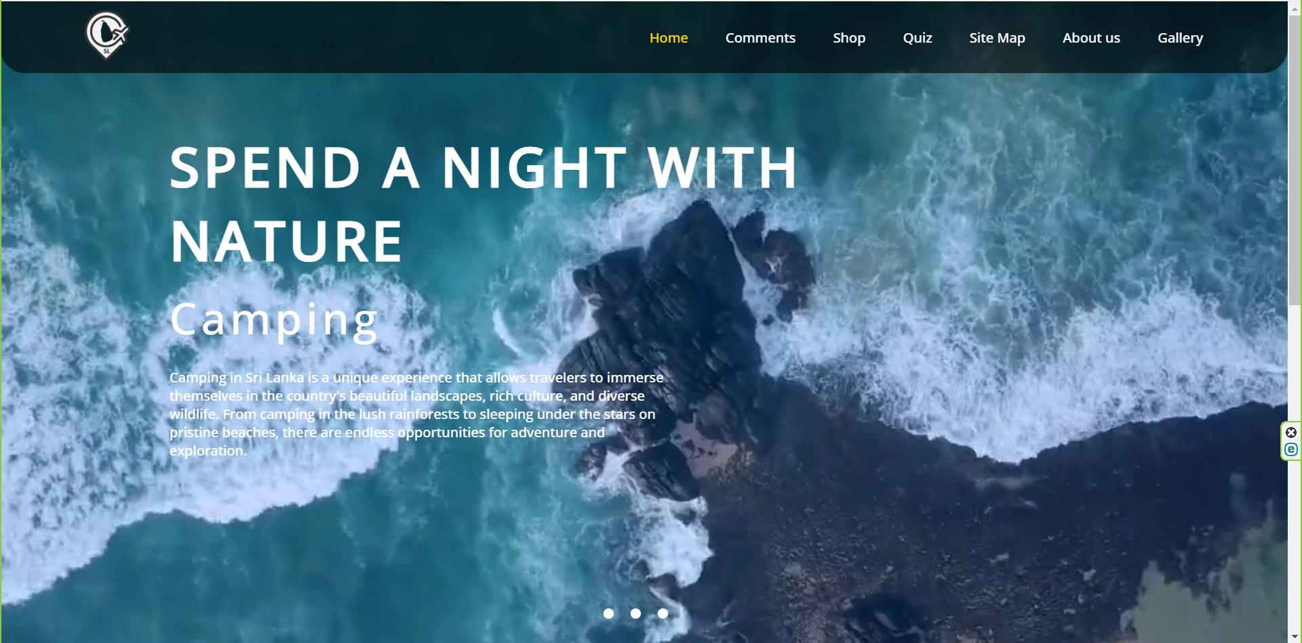

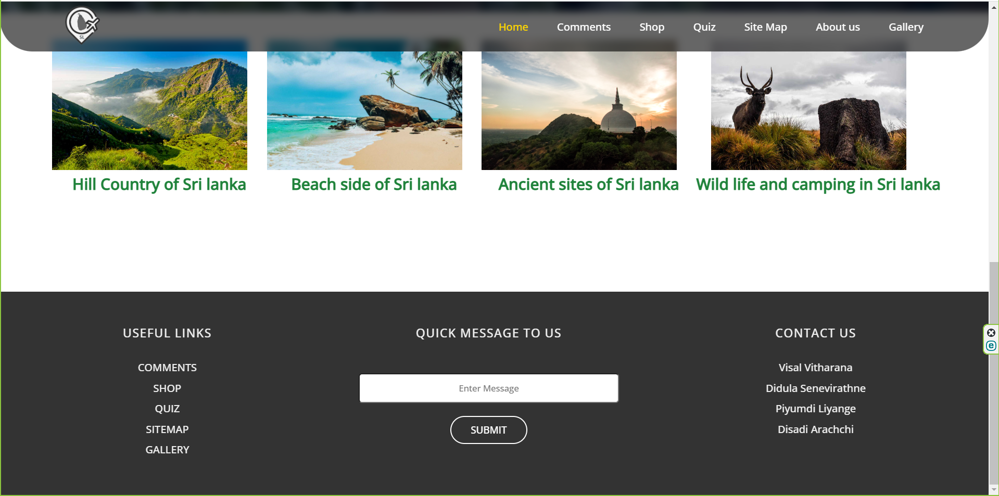

**Comments Form**

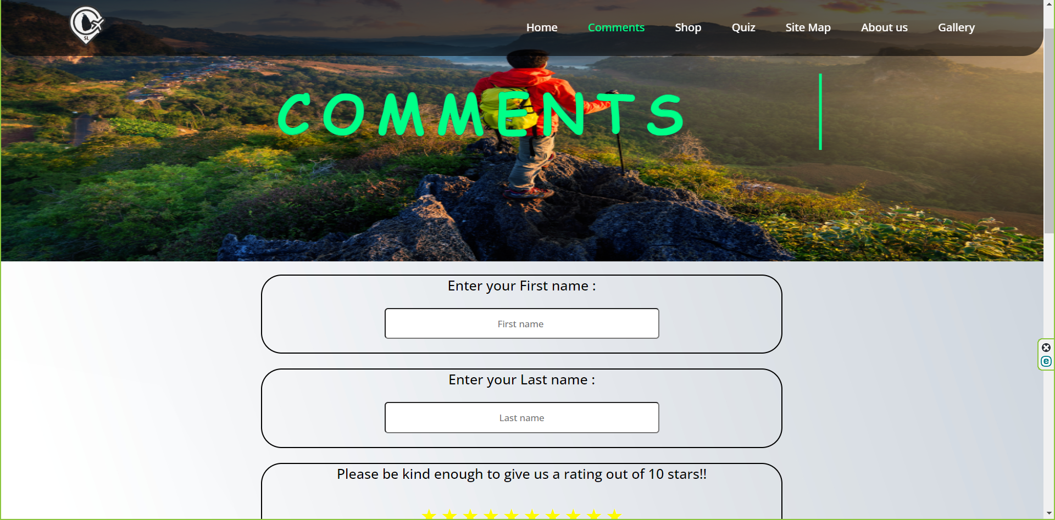

**After hovering on reason field**

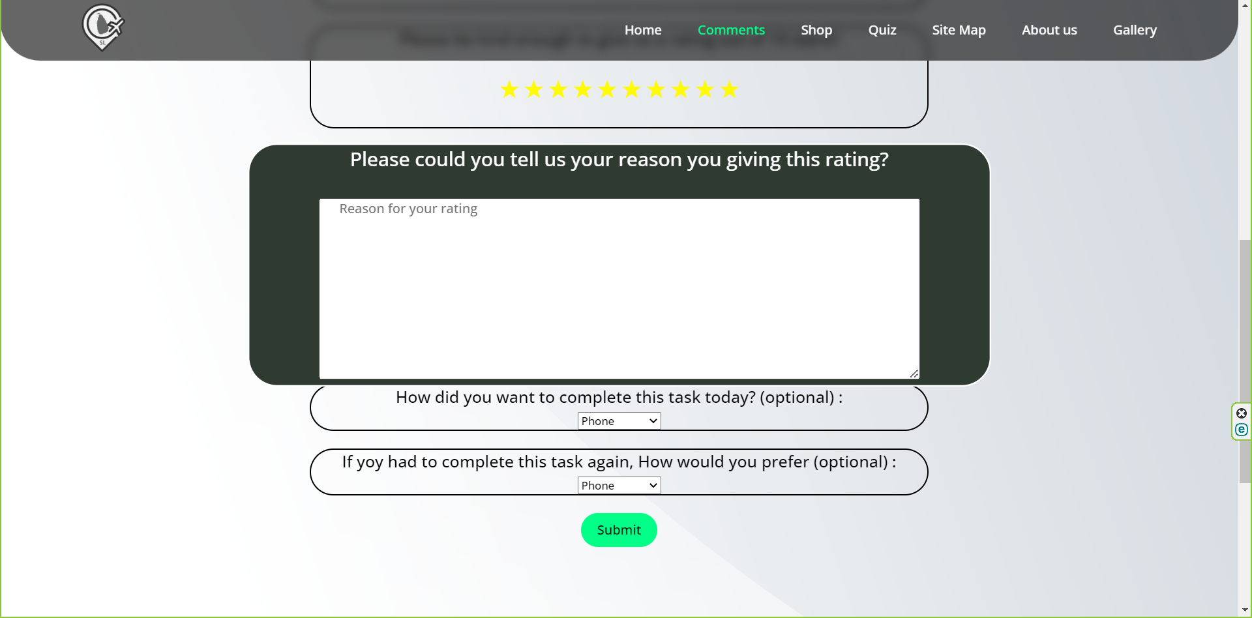

**When first or last name field is empty**

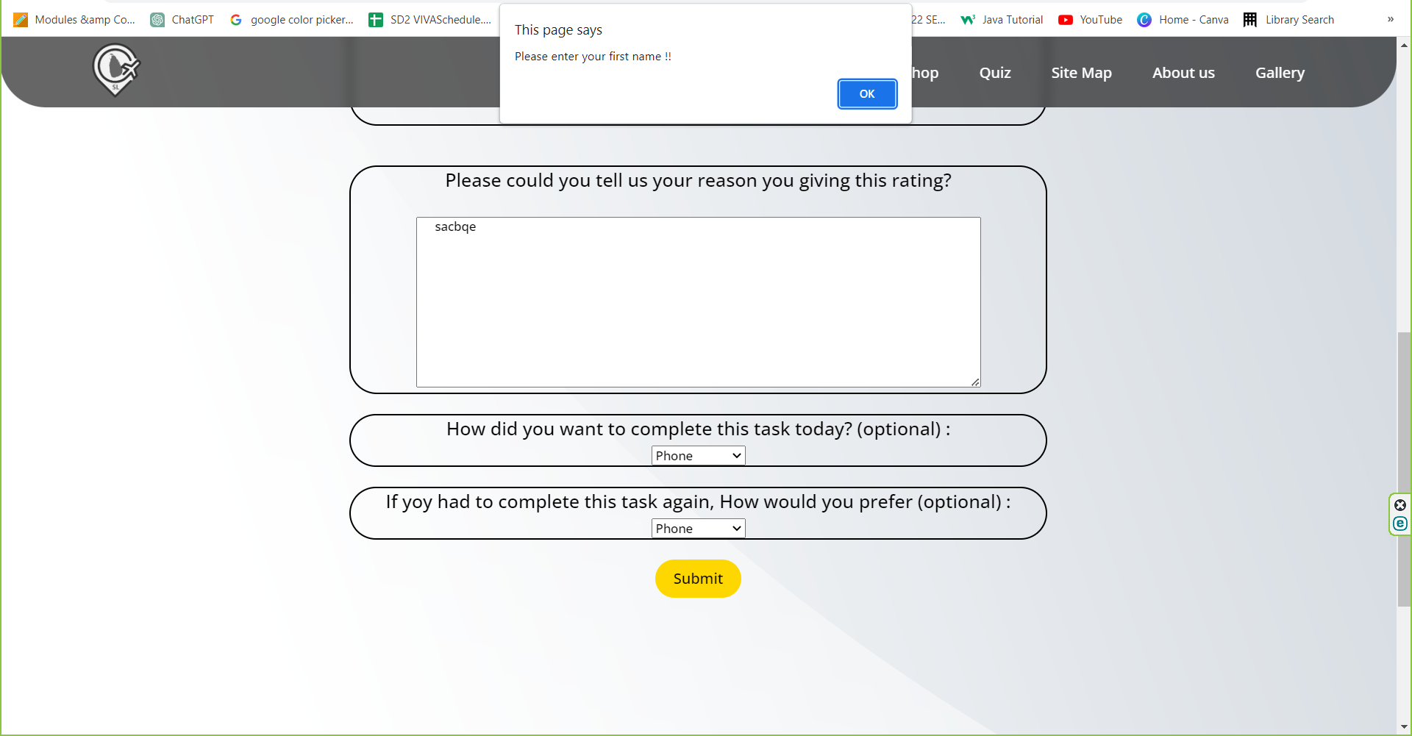

**When rating field is empty**

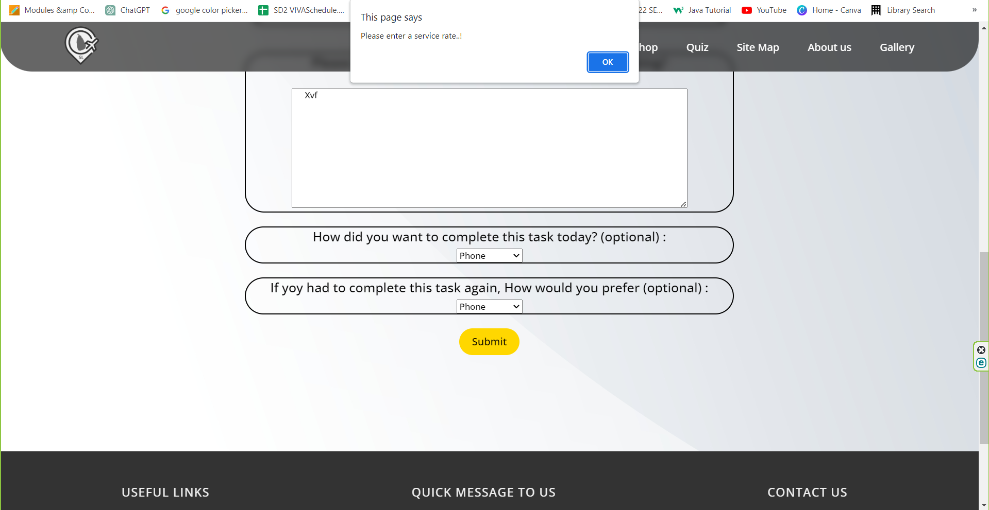

**When successful submission is done**

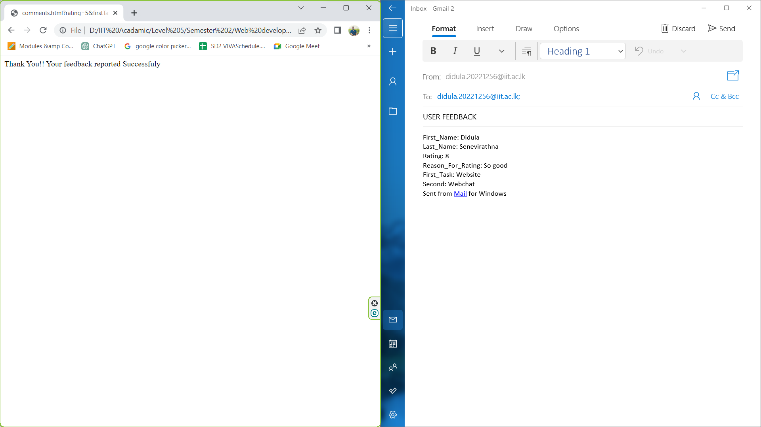

**Additional Content Page**

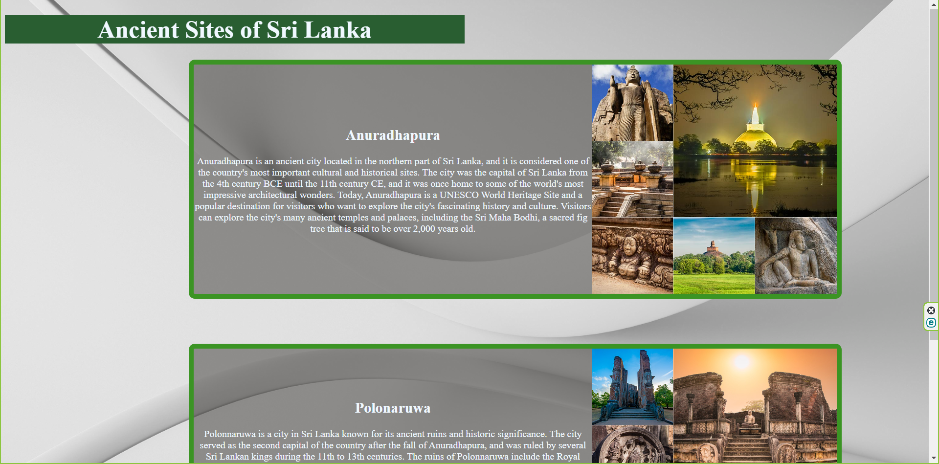

**Editor Page (After hovering on main page section)**

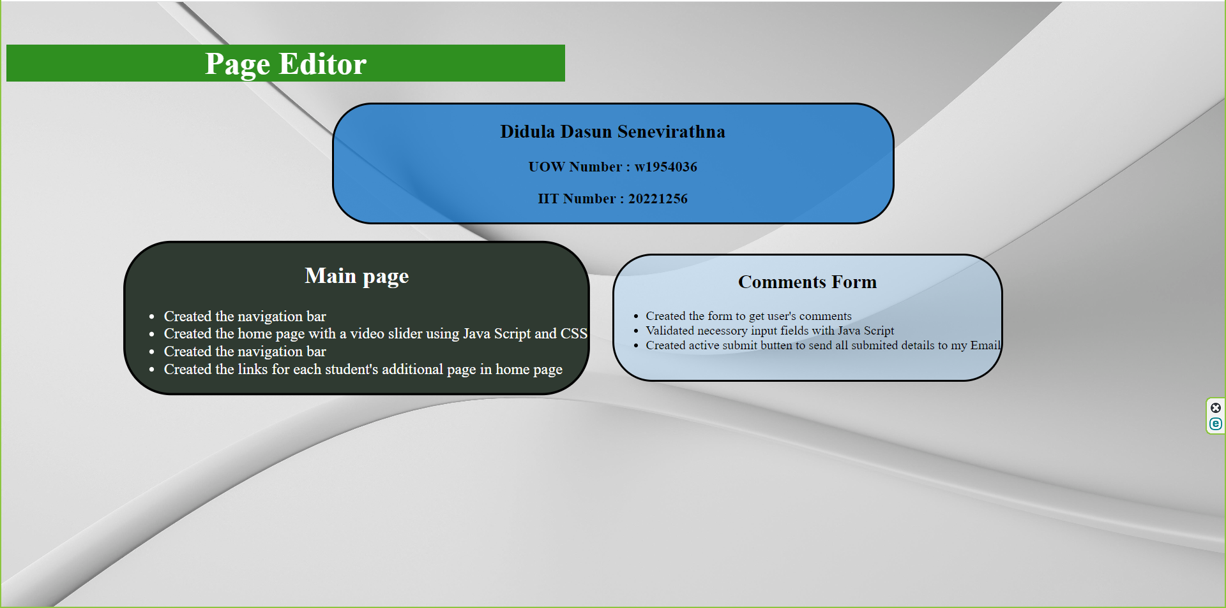

## Appendix C: Screenshots - Webpage Validation Evidence

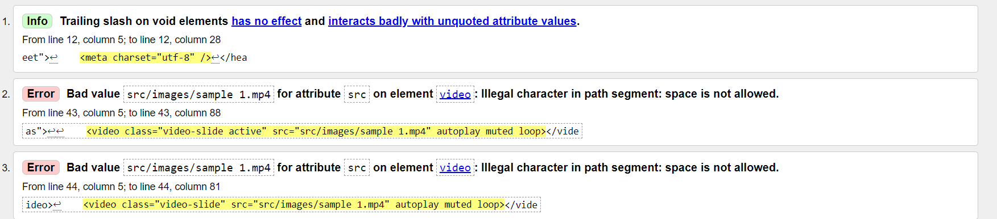

# Appendix D: Individual Statement

| Student Name: | Didula Senevirathna | Student Id: | 20221256  W1954036 |
| --- | --- | --- | --- |
| State what tasks you carried out in the project. | | | |
| Creating home page  Creating comment form  Validating comment form  Additional page  Header | | | |
| State what you enjoyed and did not enjoy about teamwork. | | | |
| Nothing didn’t enjoy. I enjoyed everything. Working as a team, Helping each other, learning from team members | | | |
| State what you learnt about teamwork. | | | |
| Teamwork is a responsibility. If you miss your part, the whole team will be lost. | | | |
| State what skills you gained/learnt from undertaking the project. | | | |
| Skills in HTML and CSS, skills on teamwork, skills on taking responsibility. | | | |
| State any strengths about yourself that emerged whilst undertaking the project. | | | |
| Taking responsibility  Time management | | | |
| State any weaknesses about yourself that emerged whilst undertaking the project. | | | |
| Sometimes lost the focus on main tasks | | | |
| State how you would do things better if you were to undertake the project again. | | | |
| Start project in the time where it is launched and use more JavaScript | | | |
| Additional general or project specific comments: | | | |
| Student 1 of our group got degue and he got a mitigation. So complete files are not assigned in this project and on student 2(my files) are added. | | | |

## Appendix E: Task Completion Checklist

Complete the table to indicate if any of your tasks were not completed or partially completed.

|  |  |  |  |  |
| --- | --- | --- | --- | --- |
| **Student 1 Tasks** | **Completed** | | | **Student Comments** |
| **Yes** | **No** | **Partially** |
| 1 - Presentation Page |  |  |  |  |
| 2a - Main (Home) Page |  |  |  |  |
| 4 - Buy products |  |  |  |  |
| 9b - External CSS (9a reused) |  |  |  |  |
| 10 - Extra content page/anchors |  |  |  |  |
| 11 - Page Editor |  |  |  |  |
| 12 - Logo/Page Editor |  |  |  |  |
| 13 - Additional Interactivity |  |  |  |  |
| 14 - Uploaded to Server |  |  |  |  |

|  |  |  |  |  |
| --- | --- | --- | --- | --- |
| **Student 2 Tasks** | **Completed** | | | **Student Comments** |
| **Yes** | **No** | **Partially** |
| 2a - Main (Home) Page | **Yes** |  |  |  |
| 2b - Main site navigation | **Yes** |  |  |  |
| 3 - Query Form | **Yes** |  |  |  |
| 9b - External CSS (9a reused) | **Yes** |  |  |  |
| 10 - Extra content page/anchors | **Yes** |  |  |  |
| 11 - Page Editor | **Yes** |  |  |  |
| 12 - Logo/Page Editor | **Yes** |  |  |  |
| 13 - Additional Interactivity | **Yes** |  |  |  |
| 14 - Uploaded to Server |  | **No** |  |  |

|  |  |  |  |  |
| --- | --- | --- | --- | --- |
| **Student 3 Tasks** | **Completed** | | | **Student Comments** |
| **Yes** | **No** | **Partially** |
| 2a - Main (Home) Page |  |  |  |  |
| 6 – Quiz |  |  |  |  |
| 8 - Student details |  |  |  |  |
| 9b - External CSS (9a reused) |  |  |  |  |
| 10 - Extra content page/anchors |  |  |  |  |
| 11 - Page Editor |  |  |  |  |
| 12 - Logo/Page Editor |  |  |  |  |
| 13 - Additional Interactivity |  |  |  |  |
| 14 - Uploaded to Server |  |  |  |  |

| **Student 4 Tasks** | **Completed** | | | **Student Comments** |
| --- | --- | --- | --- | --- |
| **Yes** | **No** | **Partially** |
| 2a - Main (Home) Page |  |  |  |  |
| 5 - Diagram (SVG) |  |  |  |  |
| 7 - Thumbnail images |  |  |  |  |
| 9b - External CSS (9a reused) |  |  |  |  |
| 10 - Extra content page/anchors |  |  |  |  |
| 11 - Page Editor |  |  |  |  |
| 12 - Logo/Page Editor |  |  |  |  |
| 13 - Additional Interactivity |  |  |  |  |
| 14 - Uploaded to Server |  |  |  |  |